NULL Value

What is NULL Value
# Source: AI Source: Provided by: [Data Path: Persons Table -> ID Column: 1, Name_En Column: Motasem Essam] -> From: [Chatgpt (GPT‑5 Mini)] on [12/10/2025]
NULL is a special marker used in databases and programming to represent the absence of a value in a field or variable.
It is different from 0, empty string, or NaN—it means “no data has been stored here.”

Key Points About NULL
# Source: AI Source: Provided by: [Data Path: Persons Table -> ID Column: 1, Name_En Column: Motasem Essam] -> From: [Chatgpt (GPT‑5 Mini)] on [12/10/2025]
- Represents missing or unknown data
  - The value is not known, not available, or intentionally left empty.
- Not the same as zero or blank
  - 0 is a numeric value.
  - '' (empty string) is a valid string.
  - NULL means no value at all.
- Used in databases and programming
  - SQL: NULL represents missing data in a table.
  - Programming languages: null, None (Python), or nil (Ruby).

Examples
# Source: AI Source: Provided by: [Data Path: Persons Table -> ID Column: 1, Name_En Column: Motasem Essam] -> From: [Chatgpt (GPT‑5 Mini)] on [12/10/2025]
In a Database Table
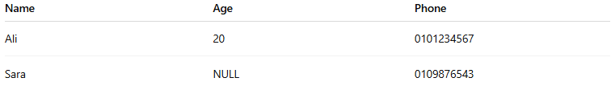
Name | Age | Phone
Ali | 20 | 0101234567
Sara | NULL | 0109876543
- NULL in Age means Sara’s age is unknown or not provided.

In Programming
# Source: AI Source: Provided by: [Data Path: Persons Table -> ID Column: 1, Name_En Column: Motasem Essam] -> From: [Chatgpt (GPT‑5 Mini)] on [12/10/2025]
Python example:
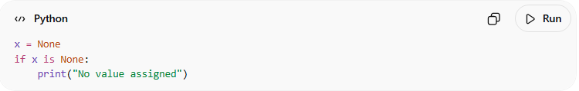
x = None
if x is None:
print("No value assigned")
Output:
No value assigned

Difference Between NULL, NaN, and N/A
# Source: AI Source: Provided by: [Data Path: Persons Table -> ID Column: 1, Name_En Column: Motasem Essam] -> From: [Chatgpt (GPT‑5 Mini)] on [12/10/2025]
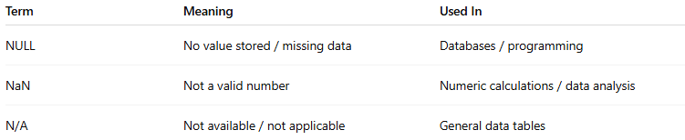
Term | Meaning | Used In
NULL | No value stored / missing data | Databases / programming
NaN | Not a valid number | Numeric calculations / data analysis
N/A | Not available / not applicable | General data tables

✅ In simple terms:
# Source: AI Source: Provided by: [Data Path: Persons Table -> ID Column: 1, Name_En Column: Motasem Essam] -> From: [Chatgpt (GPT‑5 Mini)] on [12/10/2025]
NULL means “nothing is stored here” — the data is missing or undefined.

